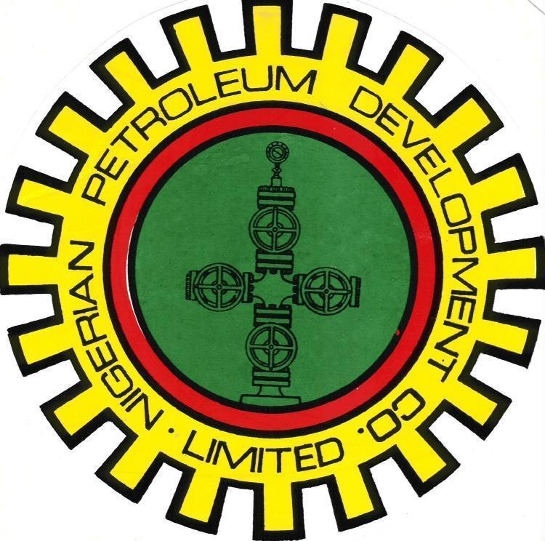
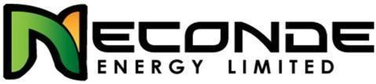

NECONDE ENERGY LIMITED

ODIDI 018T

DRAFT NITROGEN (N₂) LIFT PROGRAM

OML 42

JUNE - 2015

APPROVALS

ACTION | NAME | TITLE | SIGNATURE | DATE
Prepared by | Lawrence Mbah
Reviewed by | Oludewa Awani
Agreed by

Approved by

OBJECTIVES:
- To Nitrogen lift well back to production, by first conducting a full bore GC drift run to XN nipple.
N.B Sand clean-out or solvent dewaxing maybe required if LIB investigation warrants it.

COST & DURATION SUMMARY:
Total Cost (MM$) | 66,890.00
Total Duration (Days) | 2
N.B: Cost is based on CT & WL activity daily spread.

BASIC COMPLETION DATA:
WELL | Tree  type | Tree Connection | Tubing  Size | SCSSV  Size/type | SCSSV  Depth | Last survey/well entry
Odidi 018T | Cooper  Cameron ‘FC’ | 3-1/2” ACME | 2-7/8" 6.5Ib/ft  Drift 2.25’’(6698’)  2-3/8" 4.7Ib/ft  Drift 1.86’’(6838’) | 2-7/8” HYD OTIS ‘XEL’ LANDING NIPPLE  ‘OB-6’ SSSV + X-LOCK | 142’ | SBHP on May 2004

NB:
- Ensure well site visit is carried out to confirm X-mas tree adaptor prior to mobilization
- Conduct a well-slot visit to ensure that the well-slot is accessible for CTU operation before mobilization of CTU to site.
- Ensure completion of FLM and SLM works on wellhead, before commencement of CTU operation.

PRODUCTION DATA & WELL STATUS:
Test Date | Gross | Net Oil | BSW | GOR | THP | Bean | Present Well Status
 | bbl/d | Bopd | % | scf/bbl | psig | x/64"
01/04/2002 | 641 | 356 | 44 | 732 | 230 | 36 | C/I

SAND: D3000W
MID PERF: 6779 ftah
Known well Problem(s): The last known FTHP was 230psig in 2002. The interval may not be able to flow and will thus need nitrogen lift to kick off production.

See Appendix B attached (well completion schematics).

ROLES & RESPONSIBILITIES:
Field Engineer:
The Field Engineer is in charge of the job at the location. He should hold pre-job safety briefing and job safety analysis (JSA), issue all safety permits and has overall responsibility for all safety matters during the operation. He should submit daily progress report to the line-manager/Supervisor.
Production Supervisor:
Operate(or assign an operator to operate) the wellhead control units and tree valves at the request of the Field Engineer. He should provide directives based on standard procedure at the wellhead and or flowstation.
Production Operators:
Responsible for wellhead operations, opening and closing of wellhead valves
CT/WL Contractor
Supply certified CT/WL crew, CT/WL equipment, tools and performs operations in a safe and professional manner.
CT/WL Operator
Run CT unit, auxiliary equipment and perform operations as required, in a safe manner.
To submit a detailed report at end of exercise

NB: Invoice to be submitted along with the comprehensive CT/WL summary reports.

GENERAL SAFETY GUIDELINES FOR CT, WL & N2 OPERATIONS
- All personnel involved in the CT operation should be aware of the details of the operation, the related safety points and the areas of responsibility as outlined by the WI Supervisor in the pre-job meeting.
- Personnel shall wear, at all times, the appropriate Personal Protective Equipment (PPE) as suited for this operation. This include (but not limited to) safety shoes, hard hat, floating device, coverall, eye-google, hand-gloves, nose mask etc. The N2 Operator Must use cryogenic type hand gloves during the handling of N2 lines & hoses.
- Fire extinguishers will be available and located at a central access point during the CT operation.
- During the N2 Lift operation the work area will be designated as a hazardous area and barricaded from general access. All non-essential personnel would be informed to stay clear of the area.
- Safety harnesses must be worn when working on top of the reel, injector head or at any unsupported height above two metres where safety may be at risk.
- Clamps must be used at all times to hold the tubing other than when it is stabbed in the injector head and in operation.
- Prior to the N2 Lift activity, the CT well control equipment must be function tested and pressure tested in accordance with standard pressure test procedures.
- Treating lines must be secured with cable slings to fixed points at the opposing ends.
- Any treating lines must include a pressure relief valve (PRV) on the discharge side of the line. The discharge vent of the PRV should be positioned so that any discharged fluid or gas travels to an area remote of any personnel.
- When the CT is rigged up on the wellhead the CT Operator or a competent designated personnel must remain in the CT control cabin at all times.
- Other than when stabbing the coiled tubing into the injector head, personnel must NOT work on top of or around the CT injector head while the hydraulic circuits are activated or power pack is running.
- While the coiled tubing is in the well, all valves in line with the wellbore shall be secured in an open position by a fail-safe system. A responsible person to be assigned by the WI Supervisor shall supervise the control system continuously during CT operations.
- While the CT is rigged up on the well there will be no crane lifting operations above or in the vicinity of the CTU.
- Extreme caution will be used while handling and cutting coiled tubing. Due to the residual bend and stresses stored in the CT, it will have a tendency to spring when handled or cut. This situation will be amplified greatly if the tubing breaks or is cut while under pressure.
- When CT operations are suspended or completed, the well shall be left in a safe condition and the site shall also be left in a safe and tidy condition.
- The extremely low temperature of nitrogen (N2) in its liquid state can cause severe burns to the skin similar to that of a thermal burn. Cold nitrogen vapour can also have the same effect on delicate tissues such as those in the eyes. In its liquid form nitrogen can also cause structural damage to installations if spilt in sufficient quantities.
- Gaseous nitrogen is an asphyxiate and will displace air creating an oxygen deficient atmosphere within an enclosed area. Nitrogen vapour, when cold, is also heavier than air and will settle in low areas. Both of these factors can cause suffocation.
- Nitrogen is pumped under pressurized conditions and as with any other pressurized gas, its transfer must be carefully controlled and monitored due to the stored potential energy.
- General safety practices in well intervention to apply during the duration of the job.
- All pressure equipment (chicksans, xmas tree adapter, wire line lubricator etc) must have valid test certificate and/or test bands indicating test pressures/dates.
- NO SMOKING rule MUST be strictly enforced.
- Unauthorized person(s) must not be allowed on/around the location throughout the duration of the job.
- Carry out well head gas test using a portable gas tester prior to commencement of well entry
- All chemicals to the used onsite must be accompanied by a SHOC (safe handling of Chemical) card. Personnel MUST be aware of the hazards and mitigation.
- No environmental pollution.
- Make up connector to CT and pull test to 15,000 lbs
- Only 1502 WECO Chicksans are to be used for hooking-up all pumping lines.
- All work should be carried-out during daylight. Work should not progress under poor visibility or bad weather condition.
- Ensure the use of correctly sized tools and equipment during the job.
- Leaks should be avoided by ensuring that the lubricator and stuffing box are not leaking.
- Do not allow swab tank to fill and over-flow to avoid pollution of the area.
- Ensure all line and hoses between swab tank and well head are not leaking to avoid pollution.

EQUIPMENT REQUIRED
These may include, but not limited to the following;
- W/L unit / tools and surface equipment.
- Various sizes of gauge cutters (1.86’’ for full bore drift)
- CT unit, tools and equipment for N2-lifting, possible dewaxing and sand clean out

FRONT-END ACTIVITIES
- Validate premob certificate of CT/WL equipment and tools.
- Ensure all safety and environmental precautions have been observed
- Check and confirm that production operation is fully aware of the intended operation
- Ensure Nitrogen lift operation is carried out when flowstation is up and functional.
- Confirm from production operations that the flow-line is hooked up and not leaking.
- Check and record well head pressures before commencement of job.
- Check wellhead for integrity, check and confirm the position of the valves, ensure xmas tree valves are closed, read and record CITHP, bleed off CITHP.
- Ensure flowback tank has a flame arrestor installed in the vent stack and all hoses and lines between the flow-back tank and wellhead are in good conditions and correct pressure rating.
- Ensure the CT is pull-tested to 15000ibs okay.
- Ensure the CT BHA is function tested okay.
- Ensure PT-1 & PT-2 are conducted on the CT, pressure control equipment and CT BHA before commencement of job.

WIRE-LINE ACTIVITIES
- Check and confirm that the well is closed-in.
- Record initial wellhead pressures (CITHP, CHP) using the provided template (If casing head pressure is high, bleed off and observe if it rises again, if yes report to the office and wait for further instruction, otherwise proceed to item 3).
- Rig up Wire line BOP and lubricator on wellhead and pressure test to the CITHP for 15 minutes.
- Hook up wing arm (flow) to swab tank (environmental barge).
- M/U 1.86” GC string and RIH to 132ft ah to confirm SCSSSV in place (If any HUD is encountered, run an LIB and review job with field engineer, otherwise proceed to item 6).
- RIH GS tool and Retrieve SCSSSV at 142ft ah.
- M/U GC tool and make a drift run to XN Nipple @ 6777ftah (Tag fluid level, also record the pulling weight at every 500ft to check for drag, if drag exceeds 500lb, review job with Field engineer), POOH
- If sand or wax HUD is encountered, review job with field engineer and based on his advised, carry out sand or wax clean-out following the procedures specified below. Else proceed with nitrogen lifting the well

SAND CLEAN-OUT ACTIVITIES
    - R/U coil tubing, ensure pressure tests 1 and 2 are performed, capture tests on chart.
    - Pickle CT and surface lines on the surface with 5 bbls 15% HCl and displace into the flowback tank. Neutralize acid in flow back tank with 15% caustic soda or 30% soda ash.
    - Carry-out sand clean-out using inhibited KCl brine (0.46psi/ft or 8.8ppg).
    - Displace CT to KCl brine (0.46psi/ft) before opening the well. RIH 1.25’’ CT with SLB power-CLEAN nozzle to 50 or 100ftah above sand HUD, increase pumping rate to 0.75bpm to washout sand from the tubing at CT speed of 5 - 10ft/min. Pump 5bbls of viscous pill (or Schlumberger J572 gelling agent) every 50ftah to help suspend and transport sand debris to the surface. Perform pull test @ every 500-1000ftah.
    - Continue washing and circulating bottoms-up until returns are clear of sands. Monitor TSS/NTU of returning brine.
    - Proceed to nitrogen lift the well if the well does not flow.

SOLVENT DEWAXING ACTIVITIES
- R/U coil tubing, ensure pressure tests 1 and 2 are performed, capture tests on chart.
- Pickle CT and surface lines on the surface with 5 bbls 15% HCl and displace into the flowback tank. Neutralize acid in flow back tank with 15% caustic soda or 30% soda ash.
- RIH coil tubing/jet blaster nozzle, pump calculated volume of 40% xylene: 60% Diesel mixture. (bbls of xylene/diesel mixture required will be determined by wax- HUD depth and tubing I.D), allow to soak for 2hours minimum.
- Wash wax with diesel (jetting mode), increase circulation to 1.0bpm and reduce RIH speed to dislodge wax.
- Wash down to 6777ftah and POOH. Perform pull test every 500-1000ft. Circulate while POOH.

NITROGEN LIFTING ACTIVITIES
- Line well to Flow Back Tank
- RIH at 10ft/min until clear of wellhead valves and other restrictions, thereafter increase to 50ft/min to below fluid level and commence lifting well with nitrogen at 250-300 SCF/min (in stages of 500ft) to a maximum depth of 4000ft. If at maximum lift depth of 4000ft below fluid level, a stable flow is not achieved, call office for advice before proceeding further down hole
- With a stable flow at lift depth, commence POOH CT and reduce nitrogen rate to 200SCF/min; and with CT at 1000ft to surface, shut down nitrogen pump
- With CT on surface, observe the well for about 2hrs (depending on time) and confirm a stable flow before final rig down of Coil tubing from the wellhead
- POOH CT into injector head and close the XMT swab valve to isolate the injector head from the well flow. Continue to monitor the well.
- Bleed off all pressures above the Swab valve.
- Close the UMV and bleed off all pressures from the UMV to the Choke manifold. Close the flow line gate valve.
- Bleed off all surface pressures and record total amount of returns received in flow back tank and effluent tank.
- Rig down CT injector head and return line from the well
- Rig down Coil tubing
- Pump down all well effluent to the station by hooking up on the flowline at the wellhead.
- Do not exceed a maximum pressure of 300 psi on the flow line. Inform the operations personnel of plan to pump down the flow-line and ensure that you are properly lined up by ensuring that the flow-line plug valve downstream the wellhead and the flow-line valve at the station are both open
N.B- If the sand clean-out and solvent dewaxing is performed underbalance through the use of Nitrified brine or diesel, it is expected that the well will flow, if opened-up to production. Hence may not require N2-lifting.

WIRELINE ACTIVITIES
- Rig up wire line BOP and lubricator on wellhead and pressure test to the CITHP for 15 minutes.
- RIH X-Line to install ScSSSV at 142ftah
- POOH
- Conduct leak test on ScSSSV by venting off pressure at surface.
- Open the well on bean 24/64”
- R/D Wire Line
- Hand over well to Production.

APPENDIX A: Wellhead Pressure Recording Template
Well Name: Odidi-018T
Initial Recording | On Arrival
Date: | Time:
CITHP (psig): | CHP (psig):
Final Recording | Before Departure
Date: | Time:
CITHP (psig): | CHP (psig):

APPENDIX B: Odidi-018T Completion Schematic

